8/30/2021

Marvin Hope

219445842

Term 3 Project 2

Individual Assignment

# Content

Coding Evidence……………………………………………………………………………1

User Interface Design………………………………………………………………………2

Testing Evidence……………………………………………………………………………3

Data Design………………………………………………………………………………….4

Reflection…………………………………………………………………………………….5

LinkedIn Learning……………………………………………………………………………6

GitHub link……………………………………………………………………………………7

# Coding Evidence

In the coding evidence, this is where I will display the code of the main page of the application. The coding evidence will show the coding that I have done in the main page of the application.

In the figures 1 and 2, it will display the coding of the menu page. The menu is on the toolbar above the application. Next to the name of Student Portal, there will be 3 dots, in the 3 dots it will display the menu. In the menu it will contain the option for the user to go to a certain page on the application. Pages like Login, About and Contact.

Figure 1: MainActivity.java (Menu)

@Override  
 **public boolean** onOptionsItemSelected(@NonNull MenuItem item) {  
 **switch** (item.getItemId())  
 {  
  
 **case** R.id.***About***:  
 Toast.*makeText*(MainActivity.**this**, **"About"**, Toast.***LENGTH_SHORT***).show();  
 **return true**;  
  
 **case** R.id.***Contact***:  
 Toast.*makeText*(MainActivity.**this**, **"Contact"**, Toast.***LENGTH_SHORT***).show();  
 **return true**;  
  
 **case** R.id.***Register***:  
 Toast.*makeText*(MainActivity.**this**, **"Register"**, Toast.***LENGTH_SHORT***).show();  
 **return true**;  
  
 **default**:  
 **return super**.onOptionsItemSelected(item);  
  
 }  
  
 }  
  
 @Override  
 **public boolean** onCreatePanelMenu(**int** featureId, @NonNull Menu menu) {  
 MenuInflater inflater = getMenuInflater();  
 inflater.inflate(R.menu.***menu***,menu);  
 **return true**;  
 }  
}

Figure 2: menu.xml

*<?***xml version="1.0" encoding="utf-8"***?>*<**menu xmlns:app="http://schemas.android.com/apk/res-auto"  
 xmlns:android="http://schemas.android.com/apk/res/android"**>  
 <**item android:id="@+id/Contact"  
 android:title="Contact"** />  
 <**item android:id="@+id/About"  
 android:title="About"**/>  
 <**item android:id="@+id/Register"  
 android:title="Register"**/>  
  
</**menu**>

In figures 3 and 4, it will show the display of the button on the main page and how the button function. In figure 3, this is where I coded the button on the main page. In figure 4, it is the functionality of the button to direct the user to the Eskom loadshedding alert website.

# Figure 3: activity_main.xml (Loadshedding Button)

<**Button  
 android:id="@+id/button2"  
 android:layout_width="wrap_content"  
 android:layout_height="wrap_content"  
 android:text="Check For Loadshedding"  
 app:layout_constraintBottom_toBottomOf="parent"  
 app:layout_constraintEnd_toEndOf="parent"  
 app:layout_constraintHorizontal_bias="0.497"  
 app:layout_constraintStart_toStartOf="parent"  
 app:layout_constraintTop_toTopOf="parent"  
 app:layout_constraintVertical_bias="0.873"** />

# Figure 4: MainActivity.java (Button Functionality)

**import** androidx.annotation.NonNull;  
**import** androidx.appcompat.app.AppCompatActivity;  
  
**import** android.content.Intent;  
**import** android.net.Uri;  
**import** android.os.Bundle;  
**import** android.view.Menu;  
**import** android.view.MenuInflater;  
**import** android.view.MenuItem;  
**import** android.view.View;  
**import** android.widget.Button;  
**import** android.widget.Toast;  
  
**public class** MainActivity **extends** AppCompatActivity {  
  
 Button **btn**;  
  
 @Override  
 **protected void** onCreate(Bundle savedInstanceState) {  
 **super**.onCreate(savedInstanceState);  
 setContentView(R.layout.***activity_main***);  
  
 **btn** = findViewById(R.id.***button2***);  
  
 **btn**.setOnClickListener(**new** View.OnClickListener() {  
 @Override  
 **public void** onClick(View v) {  
 gotoUrl(**"https://loadshedding.eskom.co.za/"**);  
 }  
 });  
  
 }  
  
 **private void** gotoUrl(String s) {  
 Uri uri = Uri.*parse*(s);  
 startActivity(**new** Intent(Intent.***ACTION_VIEW***,uri));  
 }

==================================================================================

# User Interface Design

On the Main page, at the toolbar of the application it will contain a menu button and loadshedding button. The toolbar will be called Student Portal. Once the user clicks on the button below the main page, the button will redirect the user to the Eskom loadshedding alert website. Then the user can enter their location details on the website and find the times of loadshedding in that specified area.

In Figures 1 and 2, it will display the flow charts of the menu button and the loadshedding button.

Figure 1: Menu Button

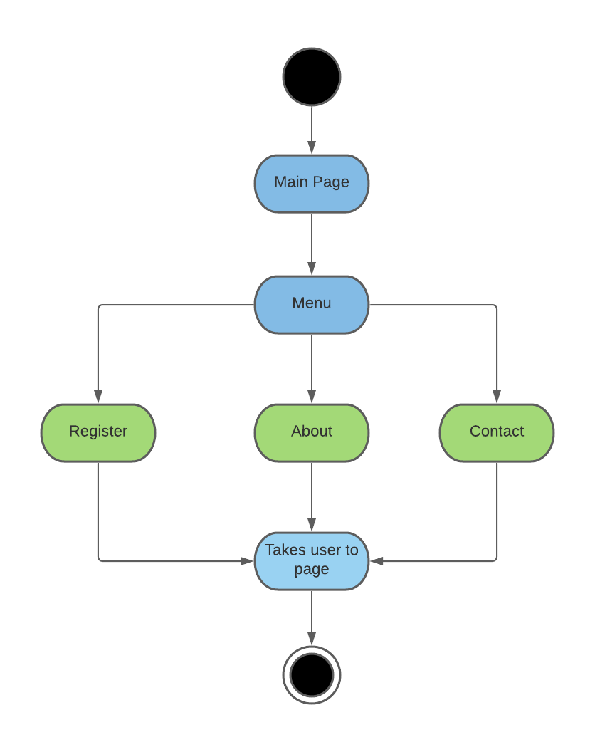

# Figure 2: Loadshedding Button

==================================================================================

# Testing

In the testing section, I will showcase the sections of the application that I did and to show evidence that it works. In the testing, I will showcase it by using my phone as proof that the page works.

In Figure 1, I will showcase the menu, the menu will give the user the ability to go back where the user desires.

# Figure 1: Menu

In figure 2,, it will showcase the loadshedding button. When the user clicks on the loadshedding button it will direct the user to their default web browser on their phone. Once in the web browser, it will show the Eskom loadshedding alert website.

# Figure 2: Loadshedding Button

In figure 3, once the user clicks on the button, it will take the user to Eskom loadshedding alert website. On the website the user can enter their location and then the website will give the user the time of loadshedding and what stage it is in.

# Figure 3: Eskom Loadshedding Alert Website

==================================================================

# Data Design

In the data design section, it will showcase activity diagram, colours of the main page, wire frame and a flow chart. In the data design section, I will incorporate some work from my term 2 assignment. The work that will incorporate from term 2 assignment, is the colour code and the wire frame.

In figure 1, this will show the colour code. In the colour code, the code is coded to display the colours that was needed for main page.

# Figure 1: Colour code

*<?***xml version="1.0" encoding="utf-8"***?>*<**resources**>  
 <**color name="purple_200"**>#FFBB86FC</**color**>  
 <**color name="purple_500"**>#0ADDCC</**color**>  
 <**color name="purple_700"**>#FF3700B3</**color**>  
 <**color name="teal_200"**>#05DFCA</**color**>  
 <**color name="teal_700"**>#FF018786</**color**>  
 <**color name="black"**>#FF000000</**color**>  
 <**color name="white"**>#FFFFFFFF</**color**>  
</**resources**>

Reference

Hope,M (2021).’Marvin Hope_219445842_Individual Task’.CPUT. Term 2 individual project (Colour code).

In figure 2, it will showcase the wireframe of the main page. In the wire frame it will show the skeleton design of the main page.

# Figure 2: Wire Frame

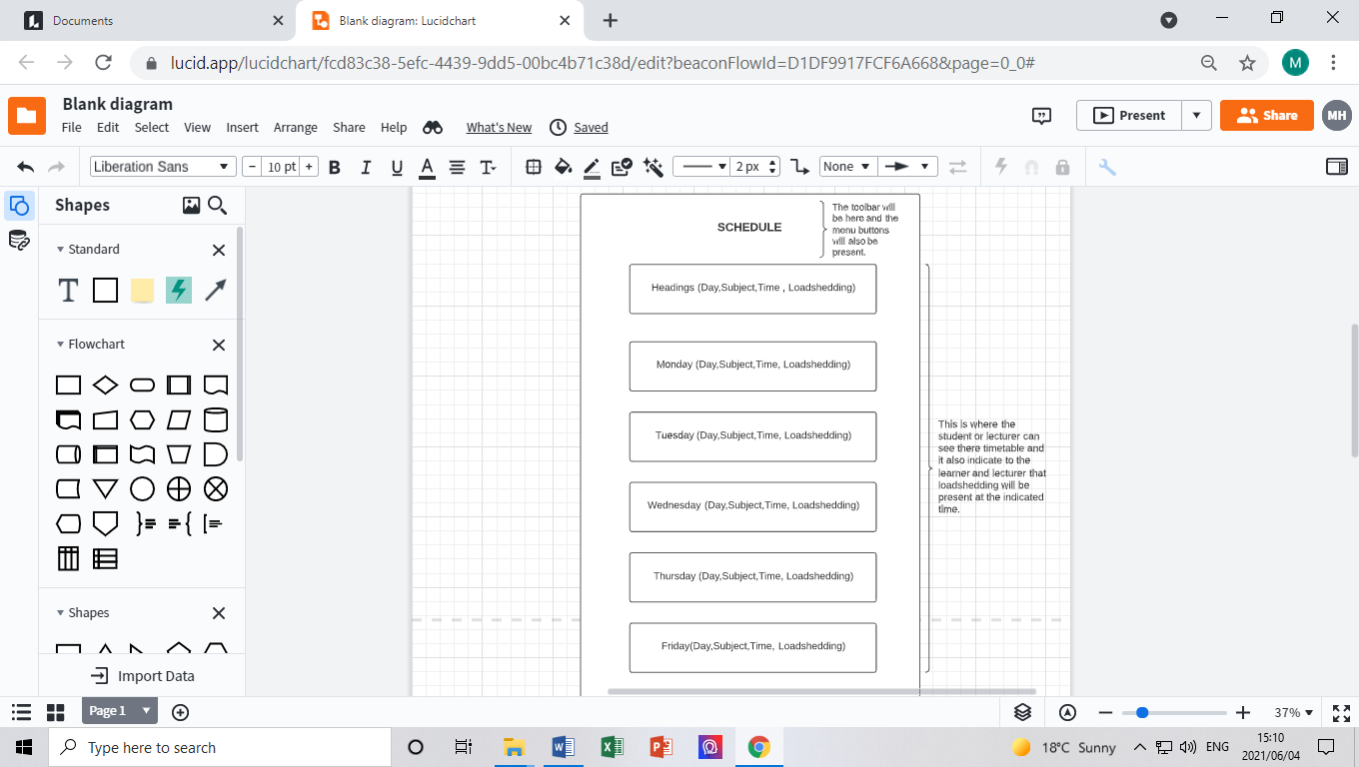

# Reference

Hope,M (2021).’Marvin Hope_219445842_Individual Task’.CPUT. Term 2 individual project (Wire Frame and design).

In figure 3, it will showcase the flow chart of the main page. In the flow chart it will show how the application will work with the corresponding pages.

# Figure 3: Flow Chart

In figure 4, it will showcase the activity diagram. In the activity diagram it will showcase how the main page will work as a whole.

# Figure 4: Activity Diagram

==================================================================================

# Reflection

I was tasked to do the main page. To make sure that the main is working and it is user friendly. I have created functionality on the main page to make sure that it is working properly.

In the reflection, by making the main page, I learned how to use my own mobile phone for my testing, I have learnt new aspects on how to use Android Studios and I have learned new coding tricks and phrases in Android studios.

All these aspects that I have learnt in project 2 so far, has made me multi-purpose programmer, that just not focus on java but other coding languages too.

==================================================================================

# LinkedIn Learning

==================================================================================

# GitHub link

Personal GitHub link

<https://github.com/Marvinhope24/Project-2/tree/Term-3-Individual-Project>

Group Link

<https://github.com/Wareezy/Project2-Term3/tree/MarvinHope-219445842>

END